**Reg. No: 21BCE1297 Name: Vidhi Shah Date: 03/03/22**

**PPS4**

**Q1**

**Aim:**

Write a program in C to find maximum and minimum element in the array.

**Procedure:**

**Input:**

Number of elements, n

Next n lines contain n numbers

**Output:**

Maximum element

Minimum element

**Algorithm:**

Step 1: Read n

Step 2: Initialise array of size n

Step 3: Using for loop read elements

Step 4: For first iteration initialise min and max to be equal to first element

Step 5: For subsequent iterations check if current element is

Smaller than min, then min = current element

Else if larger than max, then max = current element

Step 6: Display Maximum and minimum elements in separate lines

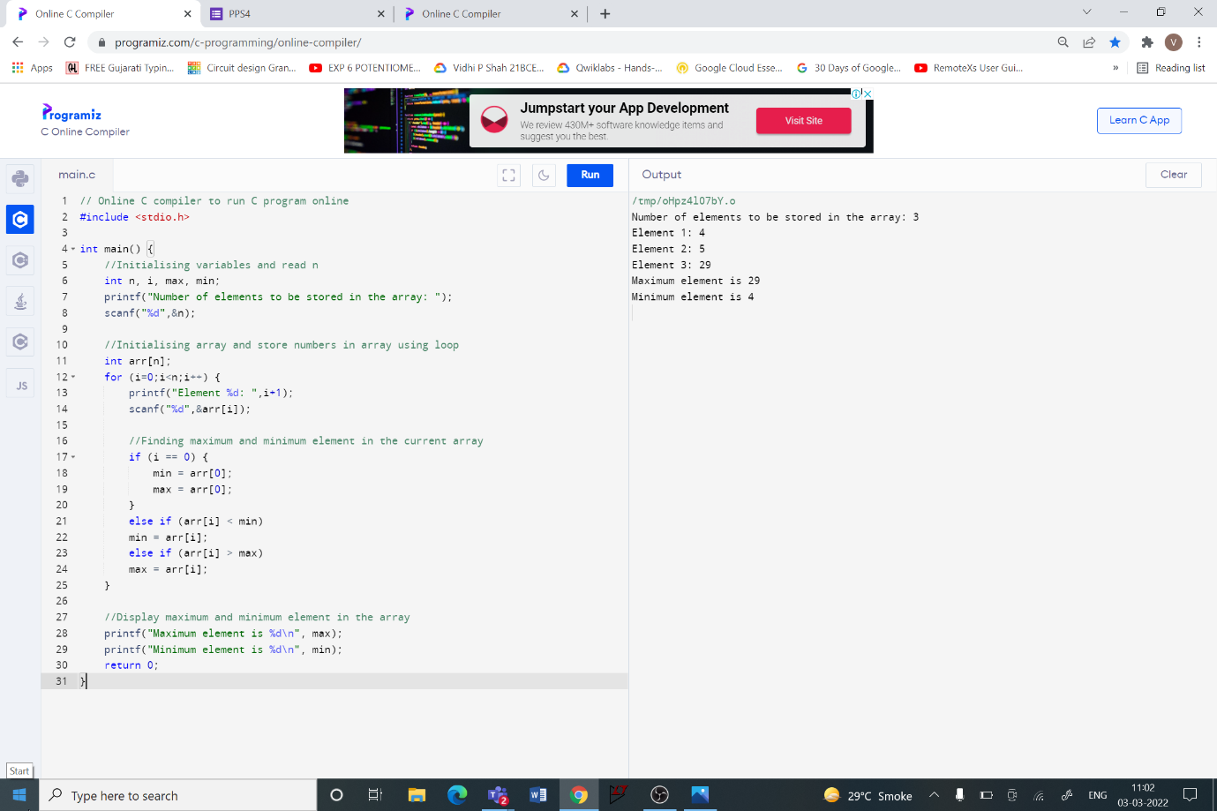**Code:**

**Q2**

**Aim:**

Write a program in C to separate odd and even integers in separate arrays.

**Procedure:**

**Input:**

Number of elements, n

Next n lines contain n numbers

**Output:**

Even elements in one line

Odd elements in next line

**Algorithm:**

Step 1: Read n, initialise o = 0 and e = 0

Step 2: Initialise array, odd array and even array of size n

Step 3: Using for loop read elements

Step 4: In each iteration check

If element is even, then store element in even array and increment e by 1

Else store element in odd array and increment o by 1

Step 5: Display even and odd elements in separate lines

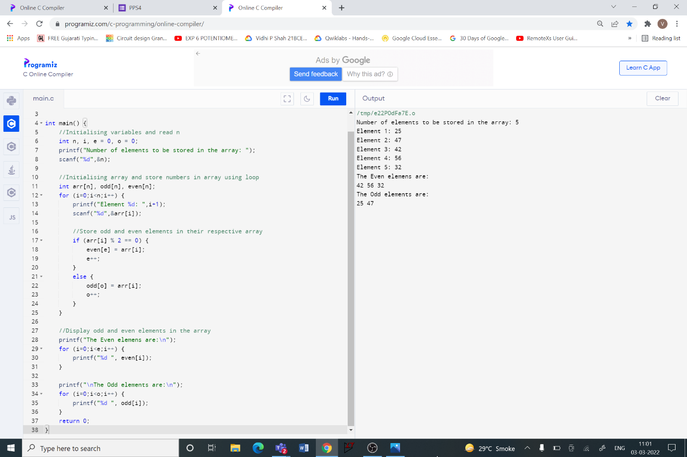**Code:**